TANFWA LOGO | TANFWA ADDRESSES

FOR OFFICIAL USE ONLY
Applicant meets the qualification [ ]
Applicant has been accepted [ ]
Application has been rejected [ ]
Membership fees has been paid [ ]

Signature………................ Date…………..
A APPLICANT’S INFORMATION
Family name (surname) | First name |  |  | Other name(s)
Your current job/title
Contacts: | Mobile:
Contacts: | Email:
Contacts: | P.O. Box:
Are you a book writer? |  |  | Yes
Are you a book writer? |  |  | No
Age:
Your academic qualifications:
Please specify your area of specialty

Please send this form, with the following
- Your Curriculum Vitae (as per the attached template below)
- Copies of your Academic Certificates
- A passport size photograph
- Your Subscription membership registration fee (TZS 50,000 OM, 20,000 students, 100,000 Associate member)
- Annual Membership Fee (TZS 30,000 Ordinary Member, 15,000 students, 150,000 Associate Member)

To:
The General Secretary,
Tanzania Academic and Non-Fiction Writers Association (TANFWA)
P.O.BOX 10070,
Dar es Salaam.

Payments can be made through T-PESA no: 0733 000 996 or NMB BANK PLC - Account No. 22510063392 – MLIMANI CITY BRANCH; ACCOUNT NAME: TANZANIA ACADEMIC AND NON-FICTION WRITERS ASSOCIATION or visit TANFWA Offices, Nzasa Road Near CRDB-UDSM Staff Quarters Sinza Dar es Salaam.

Signature: ……………………………………

Name: ……………………………………………………………

Date: ……………………………………………………….

Membership is open to all qualified Tanzanian Academic and Non-Fiction Writers irrespective of their nationalities, disciplines and academic qualifications

TANFWA CV- TEMPLATE (Please fill your details as per the attached template below)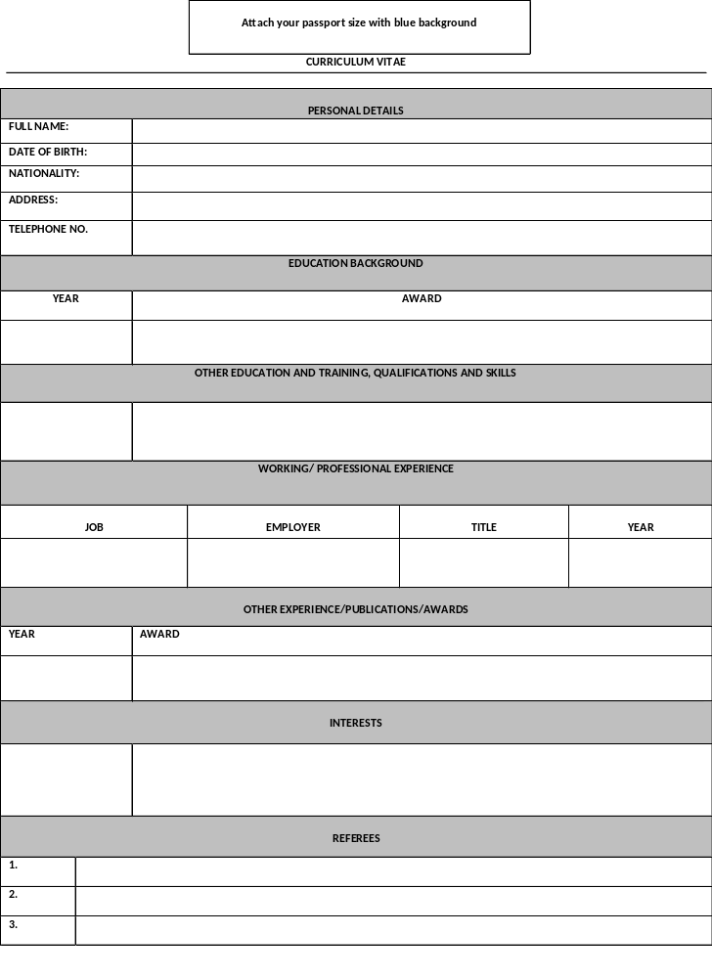Note: You can improve this form: Like list of books one has published, Title, author, publisher, date, ISBN …and other details from the current to the old ones,
Discipline: where one belongs like, Chemistry, Law, History, Education, Agriculture…..
Expertise one has: eg, Copyright, Taxation, Writing, Deisgn, IT, Instuctional design, Agric….
,,,,,,,,

